

Lab Report: 01
Course code:
CSE 2202
Course title: Algorithm Lab
Experiment Title: Insertion Sort and Selection Sort

Submitted by:
Name: Shafin Mehrab
ID: 251014058
Department: Computer Science and Engineering (CSE)

Submitted to:
Name: Fatema Khan
Lecturer, University of Liberal Arts Bangladesh

Date of submission:
30-09-2026

Contents
 | Page
Experiment Objectives | 2
Problem Statement | 2
Pseudocode | 3
Trace Table | 5
Time Complexity | 7
Implementation | 8
Discussion | 9
Conclusion | 9
References | 9

Experiment Objectives:
- Implement Insertion Sort on numbers in Descending order and Selection Sort on characters in ascending order based on ASCII order.
- Trace immediate states and record precise operations counts (element comparisons, shifts and swaps).
- Analyze and compare best-case and worst-case time complexities.

Problem Statement:
This experiment requires developing two sorting programs that take user input and display intermediate progress and final result.
Requirements:
Input | Task 1: Integer n (1 ≤ n ≤ 100) followed by signed integers in [-1000,1000] from standard input
Input | Task 2: Integer n (1 ≤ n ≤ 100) followed by n characters from standard input
Output | Task 1: Task 1: Array state after each insertion step (1 to n-1), total comparisons, total shifts, and final descending sorted array.
Output | Task 2: Array state immediately after every swap of distinct indices, total comparisons, total swaps, and final ascending sorted array.
Constraints | 1 ≤ n ≤ 100; elements bounded in [-1000, 1000] for Task 1
Constraints | Uppercase and lowercase letters treated as distinct ASCII values in Task 2

Pseudocode:
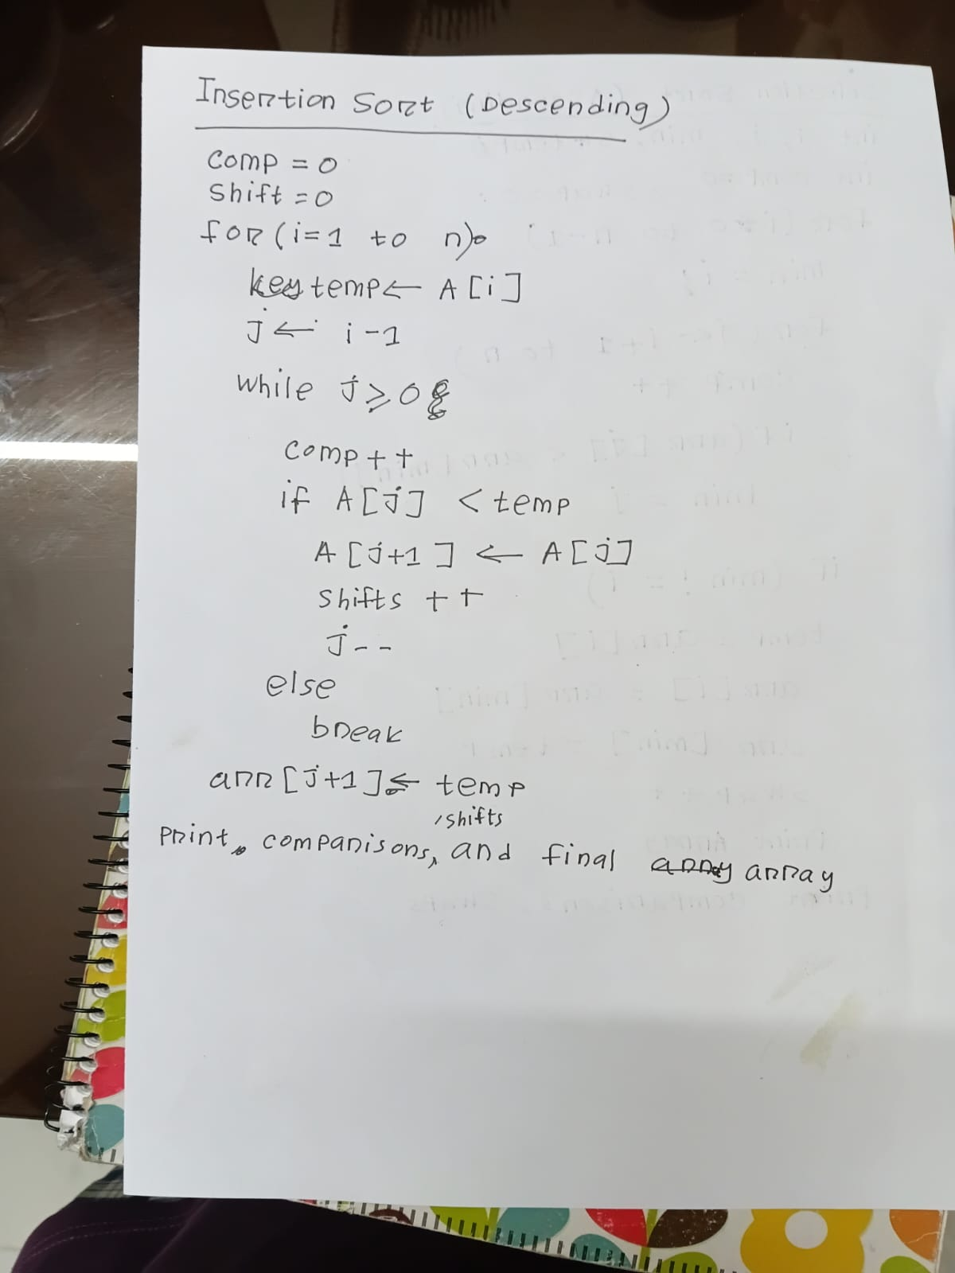
Task 1:

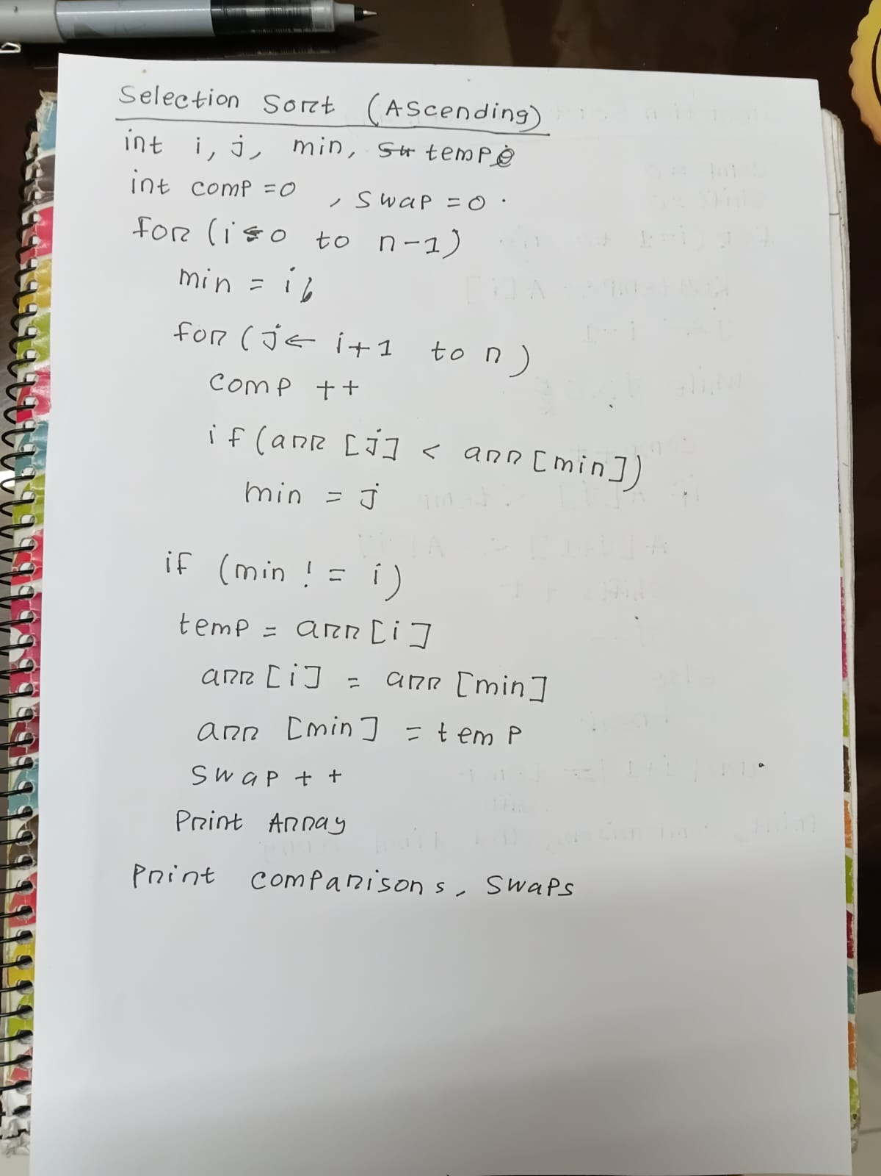
Task 2:

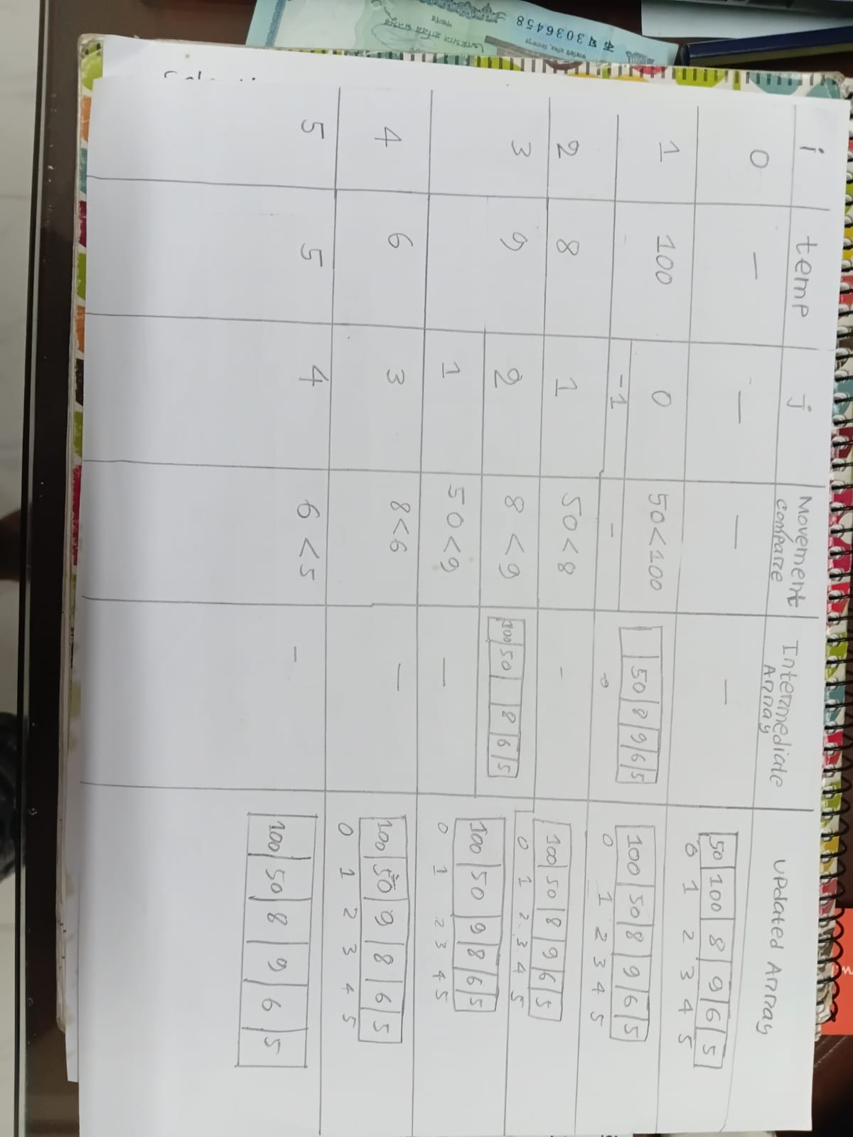
Trace Table:
Task 1:

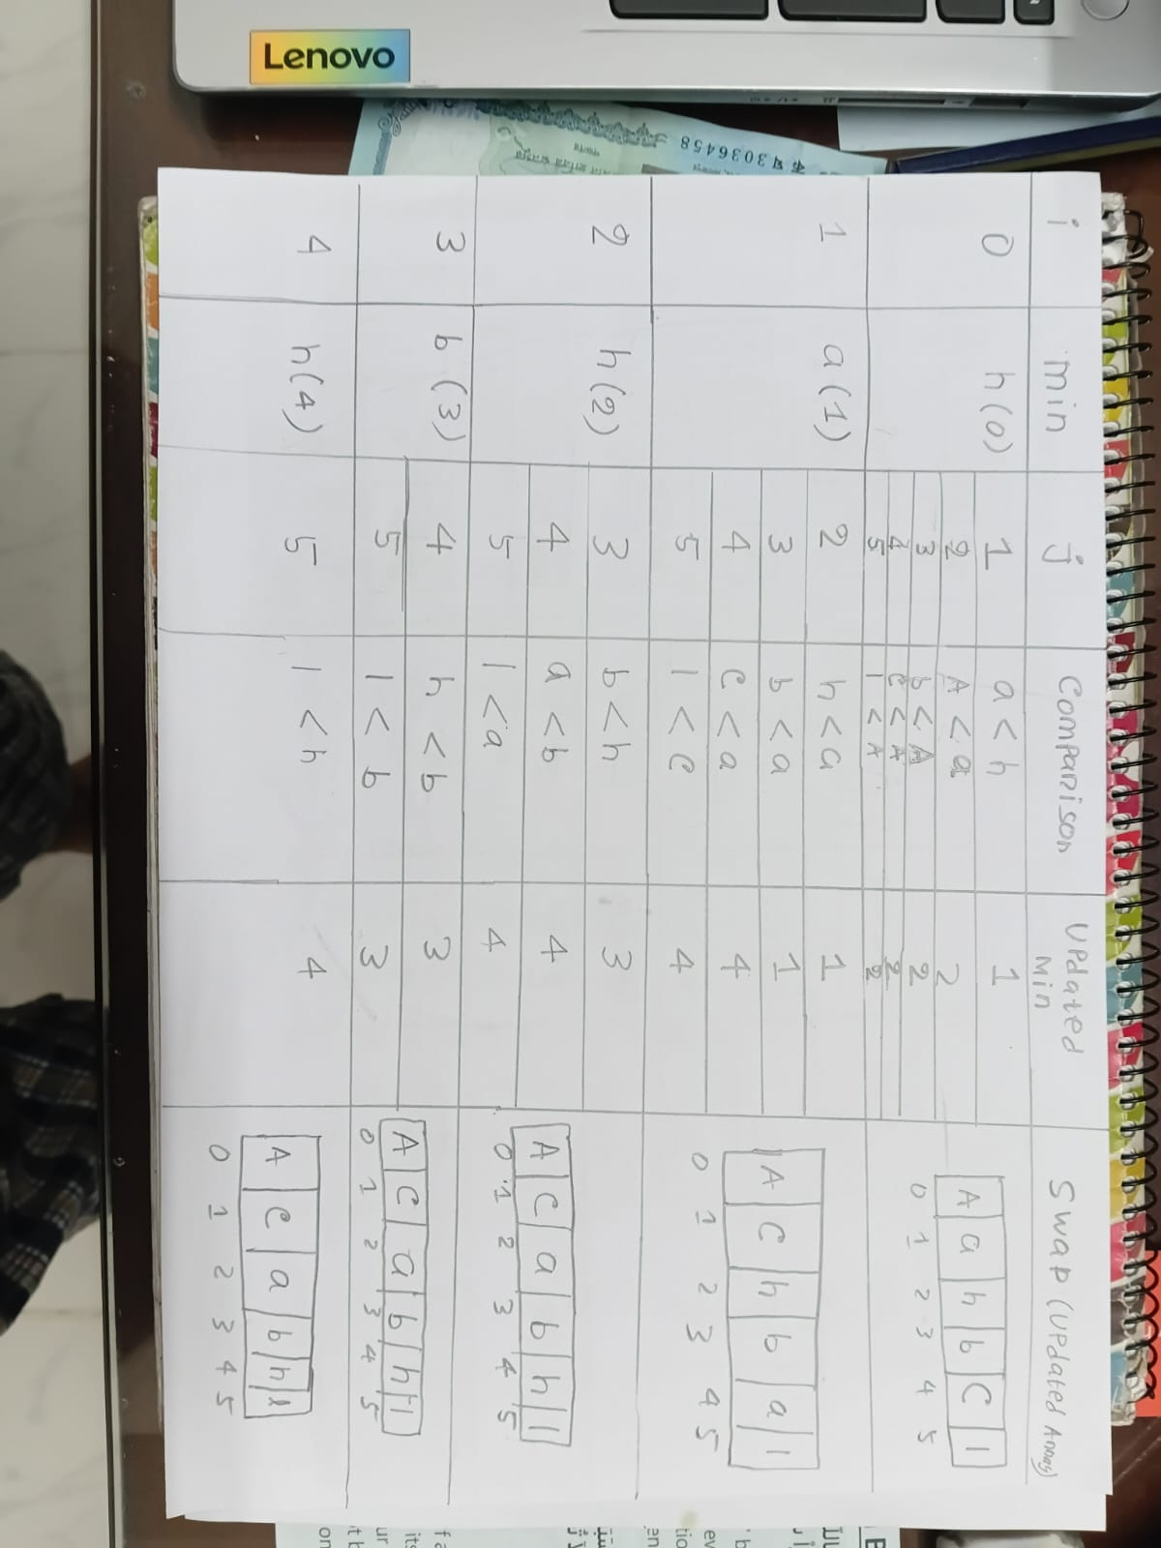
Task 2:

Time Complexity:
Task 1:
Worst Case: The outer loop runs (n-1) times. The inner loop runs i times because the array is in reverse order, preventing the break statement from executing.
Total comparisons T(n) = $\sum_{i=1}^{n-1}{i}$
T(n) = 1 + 2 + 3 + ... + (n-1)
T(n) = $\frac{\left(n-1\right)n}{2}$ = $\frac{n^{2}}{2}$ - $\frac{n}{2}$
Dropping lower-order terms and constants: O ($n^{2}$)
Best Case: The outer loop runs n-1 times. The inner loop executes exactly 1 time for each iteration before the break statement is triggered.
Total comparisons T(n) = $\sum_{i=1}^{n-1}{1}$
T(n) = 1 + 1 + 1 + ... + 1 (evaluated n-1 times)
T(n) = n - 1
Dropping lower-order terms and constants: O(n)
Average-Case Time Complexity Calculation:
The outer loop runs n-1 times. The inner loop runs i/2 times on average.
Total comparisons T(n) = sum(i/2) from i=1 to n-1
T(n) = $\frac{1}{2}$ * $\sum_{i=1}^{n-1}{1}$ = $\frac{1}{2}$ * $\frac{\left(n-1\right)n}{2}$ = $\frac{n^{2}}{4}$ - $\frac{n}{4}$
Dropping lower-order terms and constants: O ($n^{2}$).

Task 2:
Worst, Best, and Average-Case Time Complexity Calculation:
The inner loop contains no early exit conditions; it always runs to completion regardless of the initial order of the array.
The outer loop runs n-1 times. For each iteration i, the inner loop runs n - (i + 1) times.
Total comparisons T(n) = $\sum_{i=0}^{n-2}{(n-i-1)}$
Substituting k = n - i - 1, as i goes from 0 to n-2, k goes from n-1 down to 1.
T(n) = $\sum_{k=1}^{n-1}{k}$
T(n) = 1 + 2 + 3 + ... + (n-1)
T(n) = = $\frac{\left(n-1\right)n}{2}$ = $\frac{n^{2}}{2}$ - $\frac{n}{2}$
Dropping lower-order terms and constants: O ($n^{2}$)

Implementation:
- insertionSort(int arr[], int n): Sorts integers in descending order, increments comparisons and shifts, and prints intermediate passes.
- selectionSort(char arr[], int n): Locates minimum ASCII characters, increments comparisons, and conditionally swaps and prints whenever min ≠ 1.
- printArray(): Utility that outputs the current array with uniform spacing and a trailing newline.

Testing and Results:
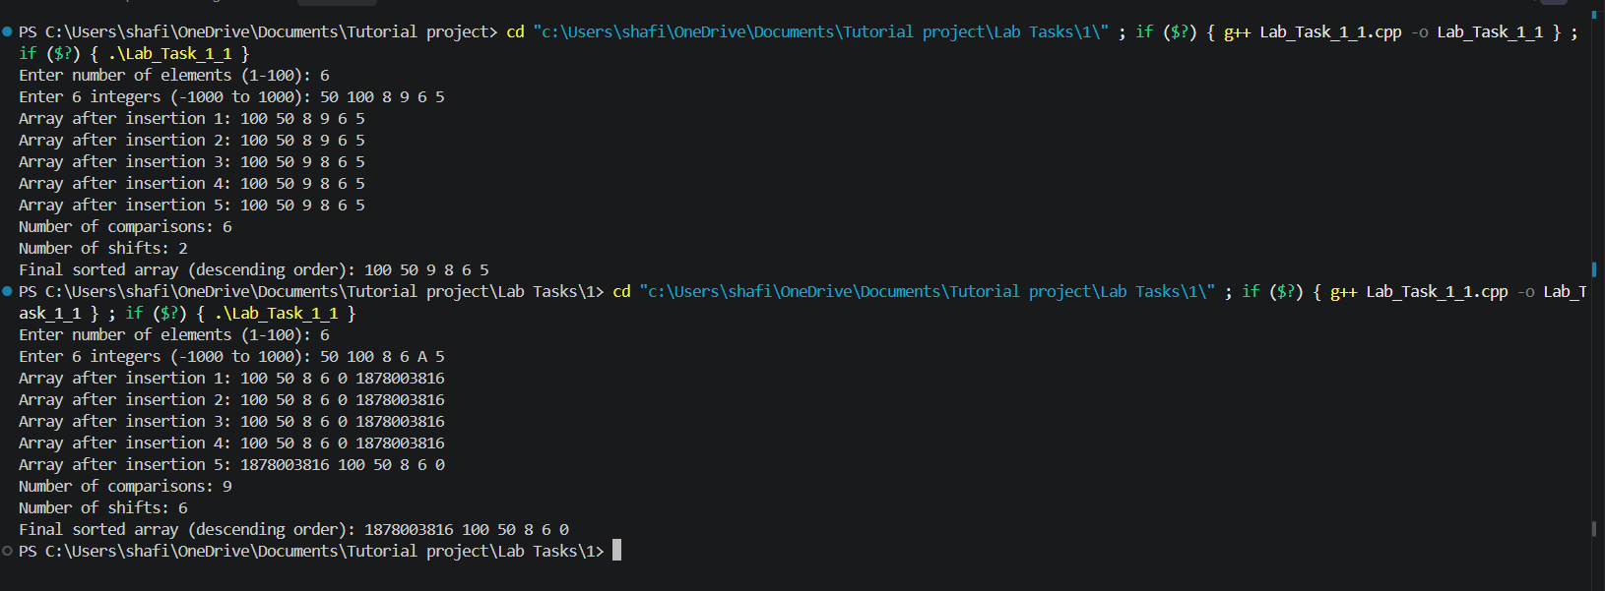
Task 1

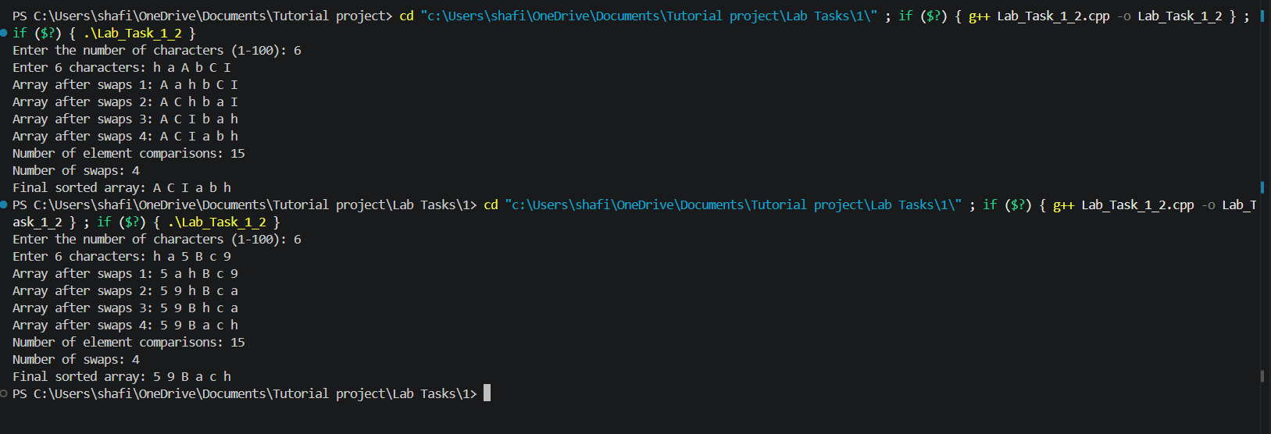
Task 2:

Discussion:
Insertion Sort is an adaptive algorithm: its comparison and shift count scale dynamically based on the input', dropping to O (n) operations when already sorted. On the other hand, Selection Sort is non-adaptive, performing $\frac{\left(n-1\right)n}{2}$ comparisons regardless of input order. However, Selection Sort minimizes data writes, performing at most n-1 memory swaps, whereas Insertion Sort performs up to O ($n^{2}$) shifts in worst-case scenarios.

Conclusion:
Both descending Insertion Sort and ASCII character Selection Sort were implemented and tested according to assignment requirements. Results proved that Insertion Sort adapts to input order with best-case O (n) time, while Selection Sort maintains a strictly quadratic O ($n^{2}$) comparison cost across all permutations. A key limitation observed is that both algorithms remain inefficient for larger input bounds (n > 1000).

References:
- No external sources used

